Turtle crossing the road

A simple game written using the built-in Python, Turtle module.

The essence of the game is that the turtle can safely cross the road without falling under the cars moving at a certain speed, when crossing the finish line, the turtle returns to the starting position, and the speed of the cars increases.

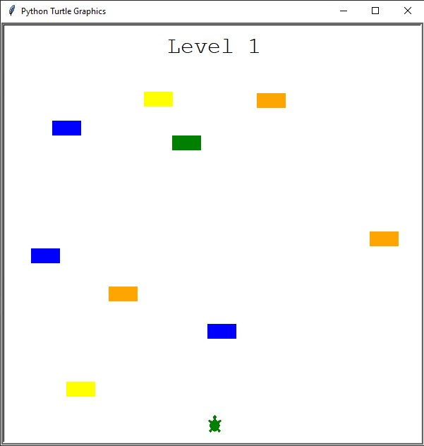

The program consists of modules: player, scoreboard, car manager.

Player describes a class using inheritance from the Turtle module, which is responsible for drawing the turtle's model, moving forward, starting position, and also crossing the finish line.

Scoreboard module describes a class that displays how many levels have been completed, or the end of the game, in the event of a turtle colliding with a car.

Car_manager module describes the random creation of cars moving at a certain speed from right to left, as well as the function of increasing the speed.